Assignment No.2

Part 1:- What will the following commands do?

Q1. echo "Hello, World!"

Ans:- echo command allow users to display lines of text/string that are passed as argument.

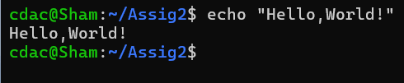

Q2. name="Productive"

Ans:-

pr1.png

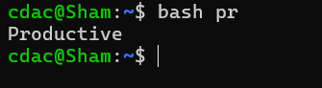

Q3. touch file.txt

Ans:- touch command allows user to create a new file in directory.

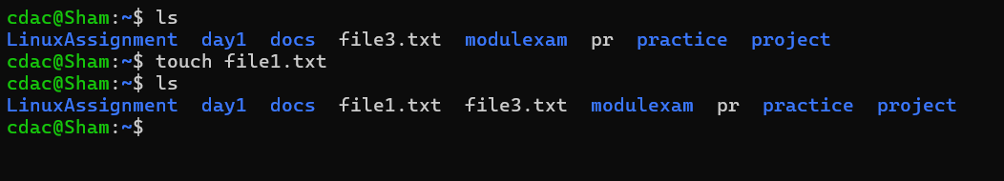

Q4. ls –a

Ans:- ls -a command represent all directory & files including hidden files



5. rm file.txt

Ans :- rm command use for the remove "file.txt".

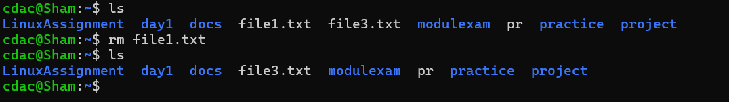

6. cp file1.txt file2.txt

Ans :-cp command use for the "file1.txt" content copy into the "file2.txt".

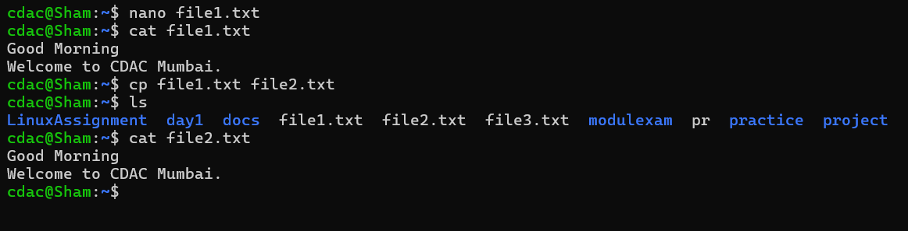

7. mv file.txt /path/to/directory/

Ans :- mv command use to move "file.txt" to the given path of directory

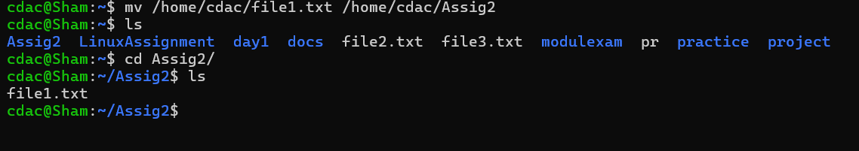

8. chmod 755 script.sh

Ans :- gives owner the full permission & read and execute script for everyone.

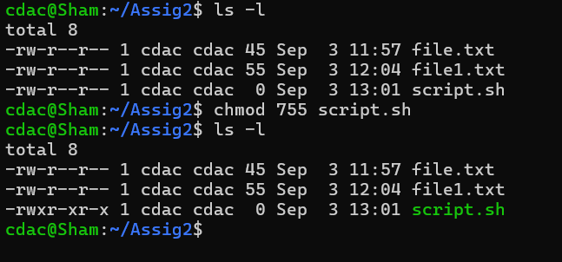+

9. grep "pattern" file.txt

Ans :- grep command used for the find specific word like "pattern" in the file "file.txt".

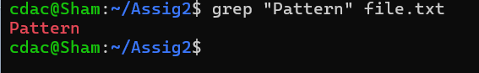

10. kill PID

Ans:- kills a single process at a time with the given process ID

11.mkdir mydir && cd mydir && touch file.txt && echo "Hello, World!" > file.txt && cat file.txt

Ans:-

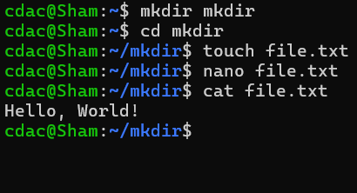

12.ls -l | grep ".txt"

Ans :- ls -l | grep ".txt" command allow user to the list of all txt files.

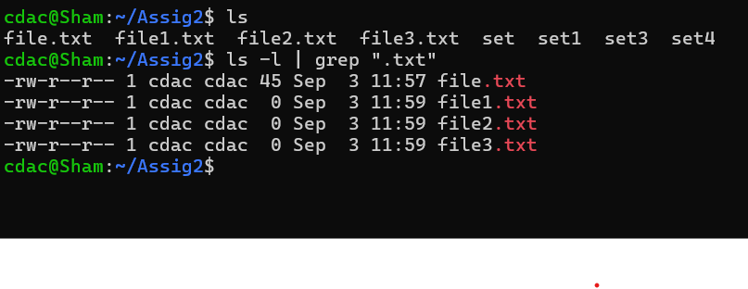

13. cat file1.txt file2.txt | sort | uniq

Ans :- Above command shows the uniq content between those files.

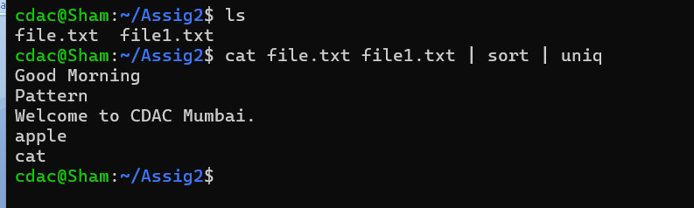

14. ls -l | grep "^d"

Ans :- Above command shows the lists of directories in current directory.

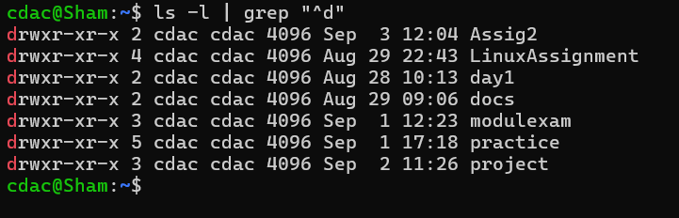

15. grep -r "pattern" /path/to/directory/

Ans:- to search for the word "example" in all files within the directory

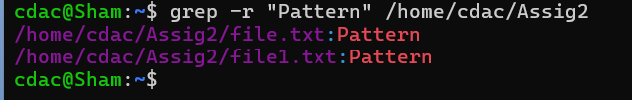

16. cat file1.txt file2.txt | sort | uniq â€“d

Ans:-

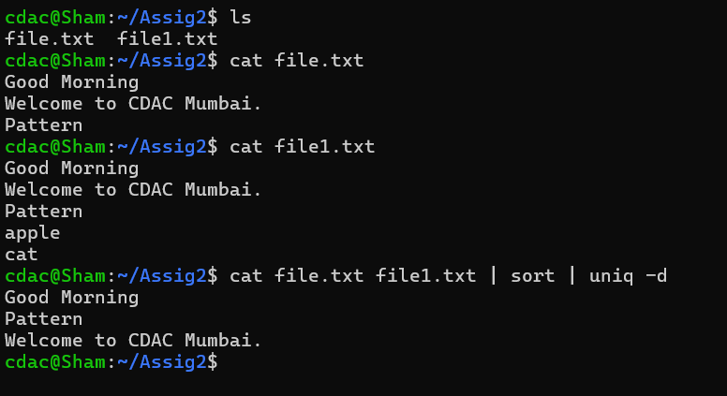

17. chmod 644 file.txt

Ans :- gives owner read and write permission. Also give read only permission to everyone for the file.txt

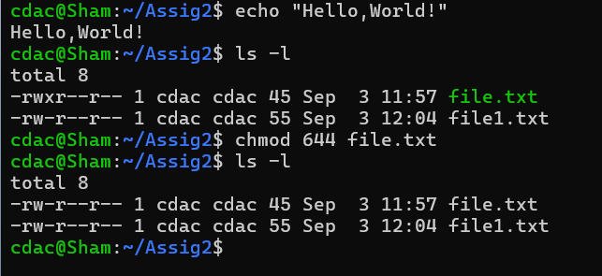

18. cp -r source_directory destination_directory

Ans:-

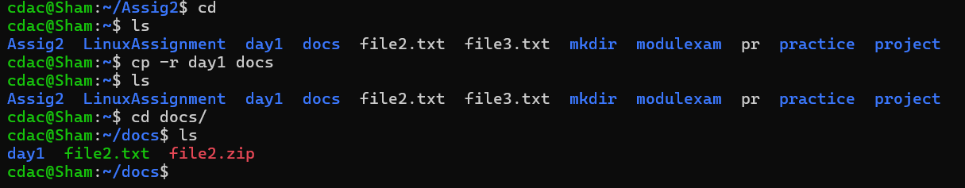

19. find /path/to/search -name "*.txt"

Ans:-

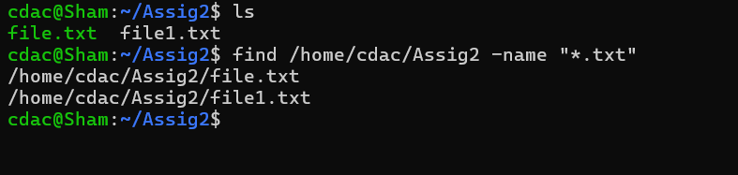

20. chmod u+x file.txt

Ans:-

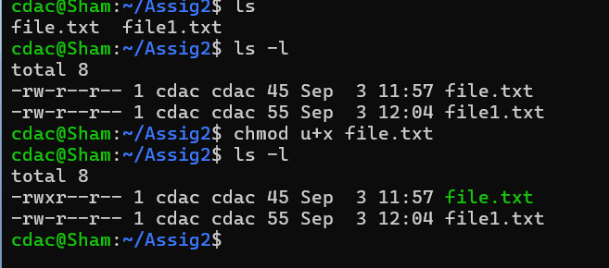

21. echo $PATH

Ans:-

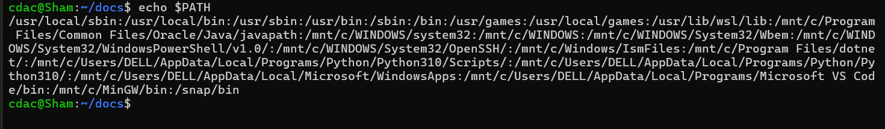

**PART B Identify True or False:**

1. ls is used to list files and directories in a directory.

Ans:- True

1. mv is used to move files and directories.

Ans:- True

1. cd is used to copy files and directories.

Ans:- False

1. pwd stands for "print working directory" and displays the current directory.

Ans:- True

1. grep is used to search for patterns in files.

Ans:- True

1. chmod 755 file.txt gives read, write, and execute permissions to the owner, and read and execute permissions to group and others.

Ans:-True

1. mkdir -p directory1/directory2 creates nested directories, creating directory2 inside directory1 if directory1 does not exist.

Ans:-True

1. rm -rf file.txt deletes a file forcefully without confirmation.

Ans:-True

**Identify the Incorrect Commands:**

1. chmodx is used to change file permissions.

Ans:-False. chmod is used to change file permissions.

1. cpy is used to copy files and directories.

Ans:- False. cp used to copy files and directories.

1. mkfile is used to create a new file.

Ans:- False. touch is used to create a new file.

1. catx is used to concatenate files.

Ans:- False. cat is used to concatenate files.

1. rn is used to rename files.

Ans:-False. cat is used to rename files.

**PART C**

Question 1: Write a shell script that prints "Hello, World!" to the terminal.

Ans:-

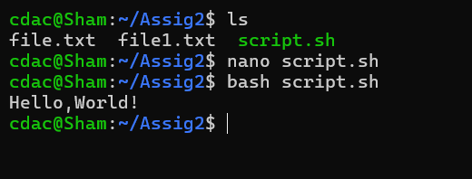

Question 2: Declare a variable named "name" and assign the value "CDAC Mumbai" to it. Print the value of the variable.

Ans:-

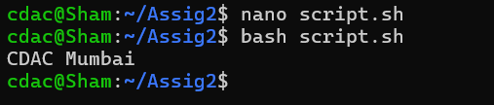

Question 3: Write a shell script that takes a number as input from the user and prints it.

Ans:-

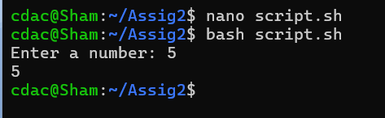

Question 4: Write a shell script that performs addition of two numbers (e.g., 5 and 3) and prints the result.

Ans:-

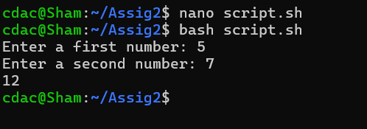

Question 5: Write a shell script that takes a number as input and prints "Even" if it is even, otherwise prints "Odd".

Ans:-

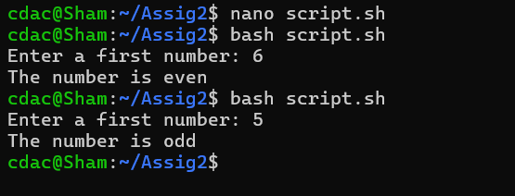

Question 6: Write a shell script that uses a for loop to print numbers from 1 to 5.

Ans:-

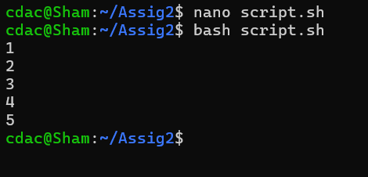

Question 7: Write a shell script that uses a while loop to print numbers from 1 to 5.

Ans:-

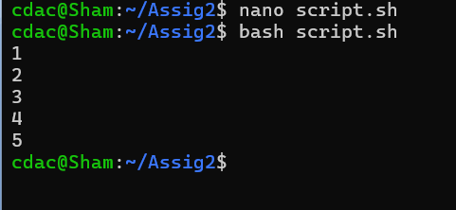

Question 8: Write a shell script that checks if a file named "file.txt" exists in the current directory. If it does, print "File exists", otherwise, print "File does not exist".

Ans:-

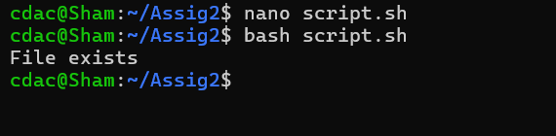

Question 9: Write a shell script that uses the if statement to check if a number is greater than 10 and prints a message accordingly.

Ans:-

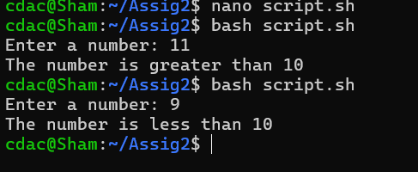

Question 10: Write a shell script that uses nested for loops to print a multiplication table for numbers from 1 to 5. The output should be formatted nicely, with each row representing a number and each column representing the multiplication result for that number.

Ans:-

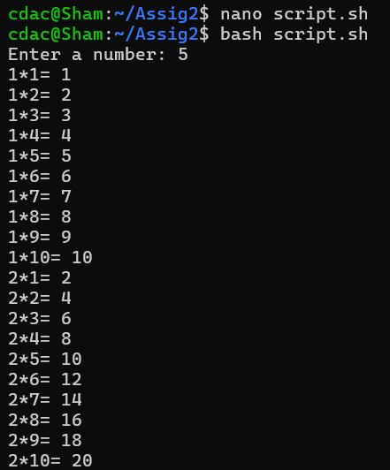



Question 11: Write a shell script that uses a while loop to read numbers from the user until the user enters a negative number. For each positive number entered, print its square. Use the break statement to exit the loop when a negative number is entered.

Ans:-

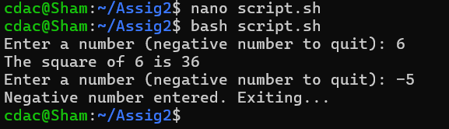

**Part E**

1. Consider the following processes with arrival times and burst times:

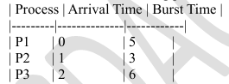

Calculate the average waiting time using First-Come, First-Served (FCFS) scheduling.

Ans:-

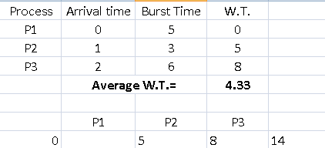

2. Consider the following processes with arrival times and burst times:

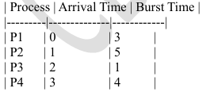

Calculate the average turnaround time using Shortest Job First (SJF) scheduling.

Ans:-

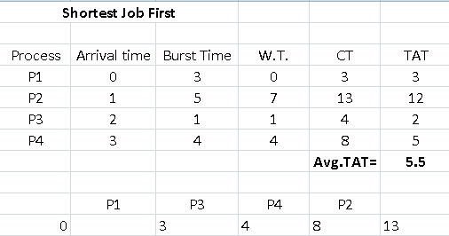

1. Consider the following processes with arrival times, burst times, and priorities (lower number indicates higher priority):

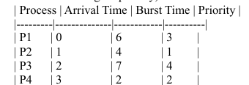

Calculate the average waiting time using Priority Scheduling.

Ans:-

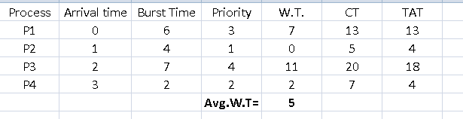

1. Consider the following processes with arrival times and burst times, and the time quantum for Round Robin scheduling is 2 units:

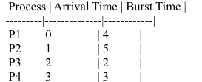

Calculate the average turnaround time using Round Robin scheduling.

Ans:-

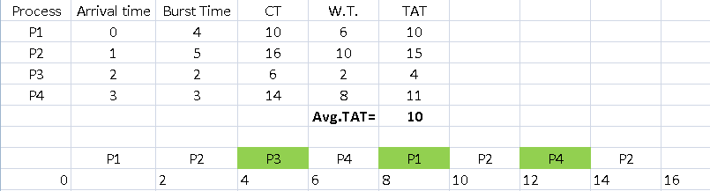

1. Consider a program that uses the fork() system call to create a child process. Initially, the parent process has a variable x with a value of 5. After forking, both the parent and child processes increment the value of x by 1. What will be the final values of x in the parent and child processes after the fork() call?

Ans:-

